1. **How many connectors are available for ingesting data in Power BI?**

These connectors cover a broad spectrum of data repositories and services, including popular databases such as SQL Server, MySQL, PostgreSQL, Oracle Database, and cloud data warehouses like Azure Synapse Analytics and Amazon Redshift. Users can also connect to cloud-based platforms such as Dynamics 365, Salesforce, Google Analytics, and Facebook to extract valuable insights from their data. Additionally, Power BI supports connectors for file-based data sources such as Excel, CSV, JSON, XML, and PDF, allowing users to import data from structured documents and spreadsheets. Furthermore, connectivity to web-based APIs, Hadoop File Systems, Azure Blob Storage, and various other online services like GitHub, Mailchimp, and MongoDB

1. **What is the sub-application included in Power BI that's used for ingesting and**

**shaping data**?

The sub-application included in Power BI that is specifically used for ingesting and shaping data is called Power Query. Power Query is a powerful data transformation tool that allows users to connect to various data sources, combine data from multiple sources, clean and transform the data, and shape it into a format suitable for analysis and visualization in Power BI.

1. **Create a manual table with 3 fields**

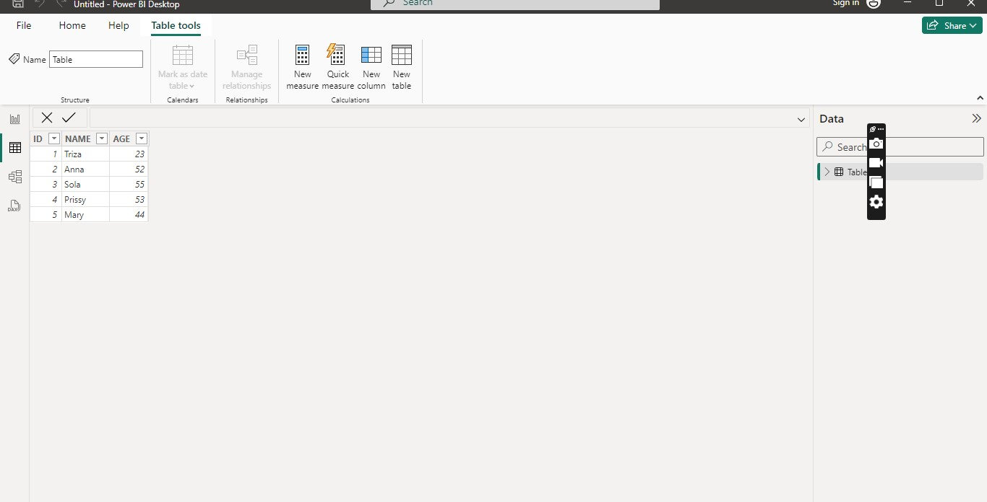

1. **Load company orders dataset into power bi and transform at least two fields for**

**analysis.**

